

**NCCUK YOUTH CAMPING**

**23 -25 JULY 2025**

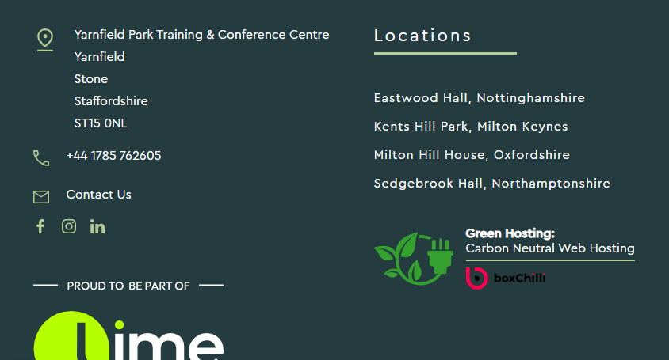

This form must be filled in by all adults and young people who are attending the youth conference. For participants under the age of 18, the form must be signed by their parent/career. Participants over the age of 18, including adults and young people living independently, should sign the form on behalf of themselves.

**Please provide the following details in respect of the PARTICIPANT**

**Full Name:----------------------------- Date of Birth-----------------------------------**

**Home address including post code:**

**Mobile Phone (if applicable):---------------------------**

**Participant’s Doctor’s contact details: NHS number: -----------------------**

**Doctor’s Name:**

**Address including post code:_____________** Telephone:_________________

Give details of any medical conditions e.g. diabetes, epilepsy, allergies etc.:

Please give details of all current medical treatment, including medication:

Special Dietary Requirements (including food allergies):

**Please provide the following details in respect of the PARTICIPANT**

**Full Name:**

Relationship to Participant (e.g. mother): **Telephone (including STD**

**Code):**

How should they be contacted in an emergency**? Home:**

**Work:**

**Mobile:**

**Home address:**

**Declaration of consent**

**I acknowledge the receipt of and understand the information of the proposed youth**

**Conference.**

**1. I consent to the above named Participant taking part in the conference.**

**2. I agree/do not agree (please delete as appropriate) that the staff on the**

**Conference can give permission for the Participant to have any medical treatment**

**that medical authorities think necessary, including an aesthetic and blood**

**transfusion. If agreement is not given the signatory/next of kin must undertake to**

**be contactable at all times in the event of an emergency so that any responsibility**

**for decisions affecting the participant can be made by the signatory/next of kin.**

**Signed: …………………………Date: ……………………………….**

**Relationship to the Participant:……………………………………..**